|  |  |
| --- | --- |
| *ENGR 132 Team Poster* | *Spring 2017* |
| *Section <005>* | *Team <12>* |

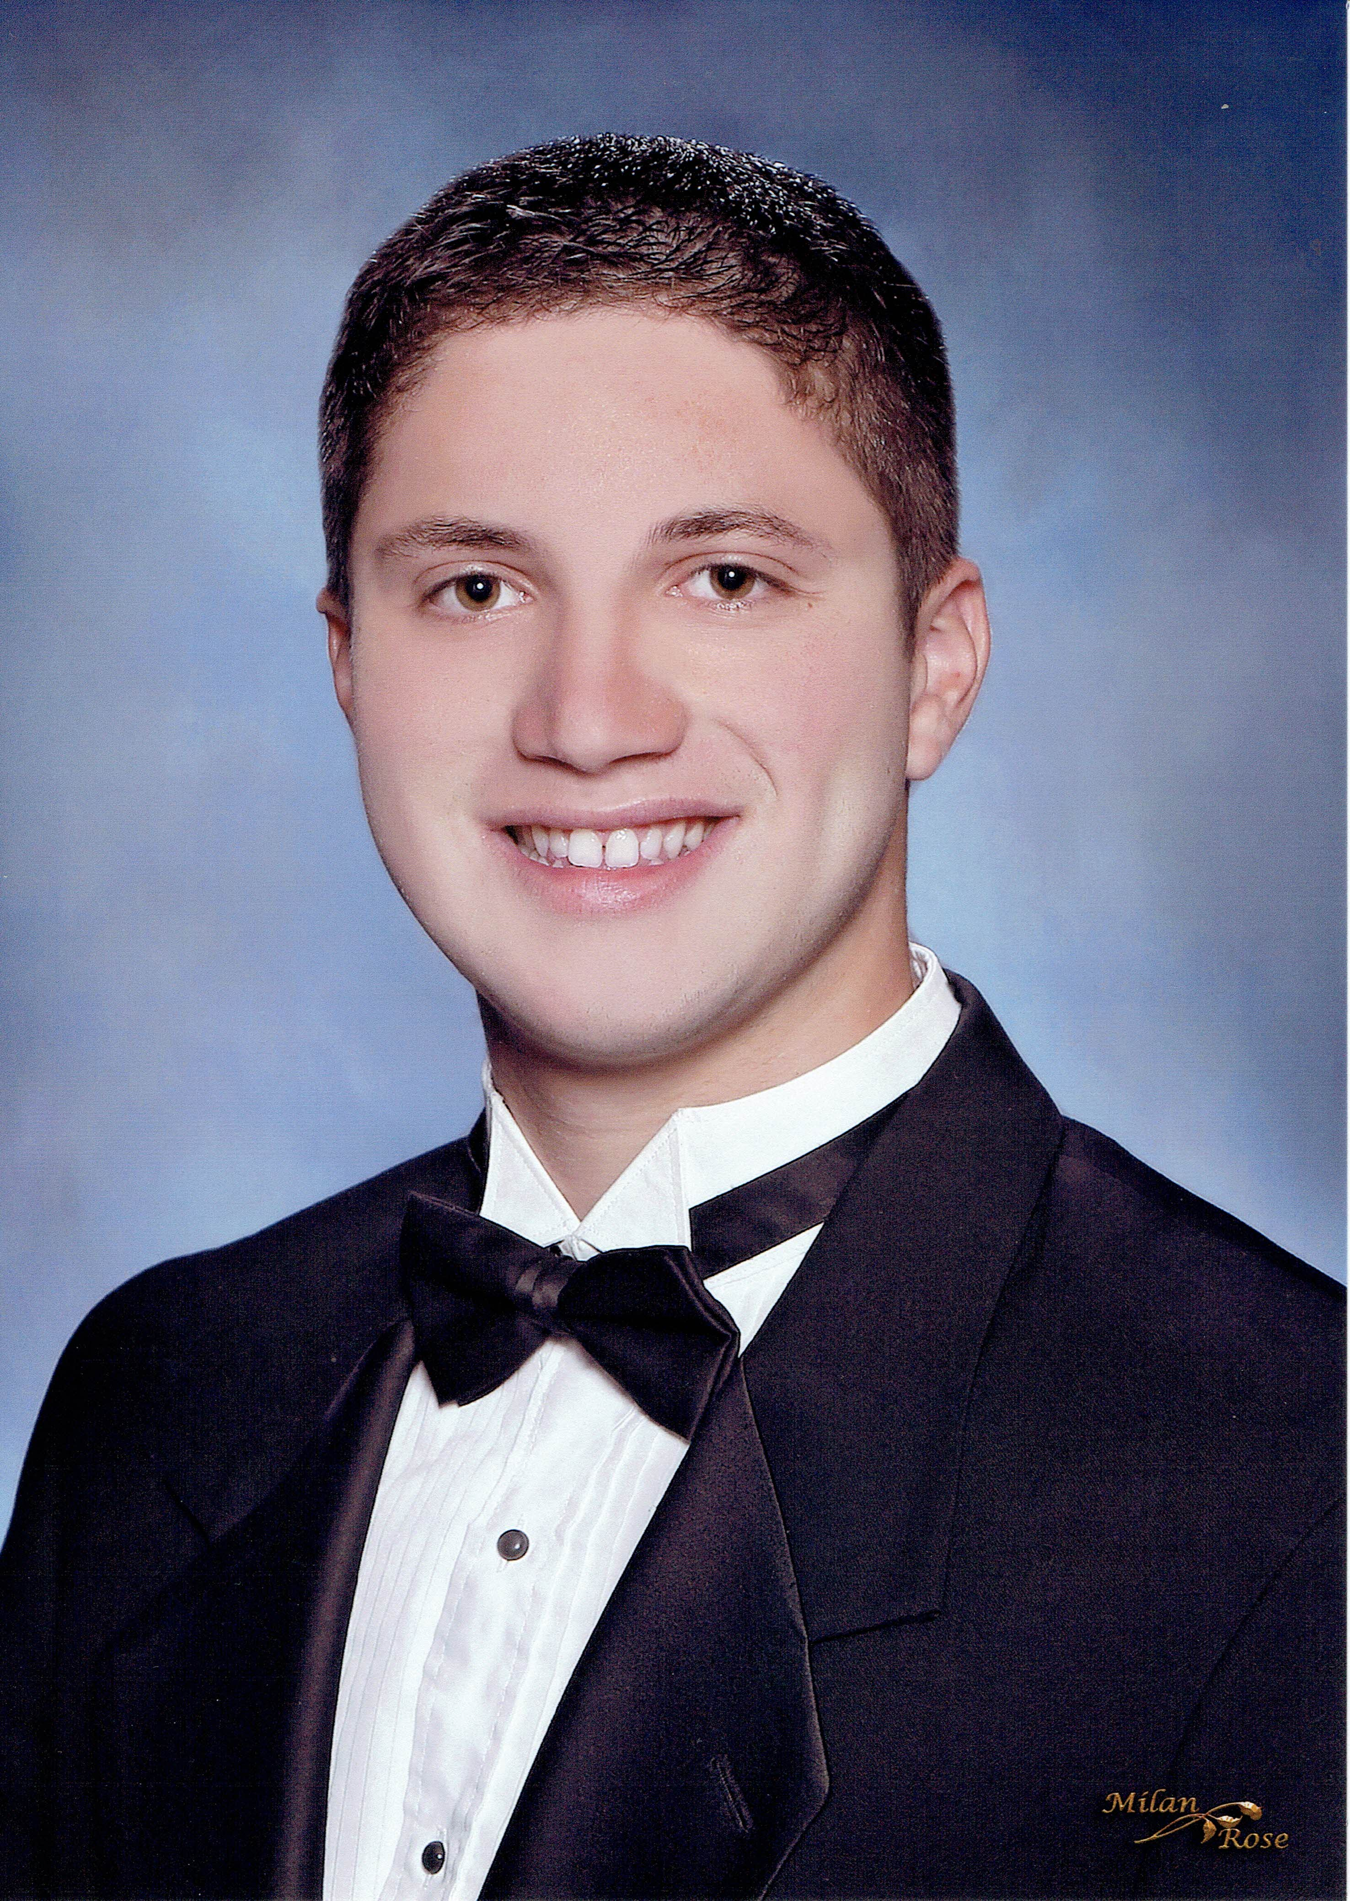

Andrew Sartorio

Harith Kolaganti

From Skillman, NJ. Swam and boxed in high school, enjoy playing the guitar and bass. Wants to be chemical engineer.

From Edison, NJ. Did track and field in high school, and really enjoys coding and other aspects of engineering. Wants to be in Aerospace





Vedant Raghavan

Tyler Huter

From India, lives in Dubai. Loves coding and is extremely organized. Maintains high leadership qualities.

My hometown is Chennai in India but I've lived my whole life in Dubai.

From Fishers, Indiana, enjoys playing percussion music and sleeping, wants to be a computer electrical engineer

Jersey Boys and Friends

**All team members must sign the table below. *Your signature below indicates your approval of this team poster.***

|  |  |  |  |
| --- | --- | --- | --- |
| 1 |  | 3 |  |
| 2 |  | 4 |  |